Bug Report

# 1. Bug Details

* **Bug ID:** BR-001
* **Title:** Incorrect Appointment Date
* **Module:** Appointment Module
* **Severity:** High
* **Priority:** Medium

#### **2. Bug Description**

When scheduling a new appointment, the selected date is displayed incorrectly in the appointment confirmation screen.

#### **3. Steps to Reproduce**

1. Log in to the system.
2. Navigate to the Appointment Module.
3. Click on the "Schedule Appointment" button.
4. Select a date in the calendar picker.
5. Fill in the required appointment details.
6. Submit the appointment form.
7. Observe the appointment confirmation screen.

#### **4. Expected Result**

The appointment confirmation screen should display the selected date accurately, matching the chosen date in the calendar picker.

#### **5. Actual Result**

The appointment confirmation screen displays the selected date one day ahead of the chosen date in the calendar picker.

#### **6. Screenshots**

Attach screenshots (if applicable) that demonstrate the issue.

#### **7. Additional Information**

* Browser: Google Chrome, version 92.0.4515.159
* Operating System: Windows 10
* Date/Time of Occurrence: September 15, 2023, 10:30 AM

#### **8. Impact**

The incorrect date display may cause confusion for users and lead to scheduling errors. It could result in missed appointments or incorrect allocation of resources.

#### **9. Reproducibility**

The issue is reproducible consistently by following the steps mentioned above.

# 1. Bug Details

* **Bug ID:** BR-002
* **Title:** Empty Response body in Get Booked appointment request
* **Module:** Appointment Module
* **Severity:** High
* **Priority:** high

### **2. Bug Description**

After scheduling a new appointment, the new appointment is not shown on the appointment page.

### **3. Steps to Reproduce**

1. Log in to the system.
2. Navigate to the Appointment Module.
3. Click on the "Schedule Appointment" button.
4. Select a date in the calendar picker.
5. Fill in the required appointment details.
6. Submit the appointment form.
7. Navigate to the appointments screen.

### 

### 

### **4. Expected Result**

The appointments screen should display the new appointment in front.

### **5. Actual Result**

The appointment screen displays nothing.

### **6. Screenshots**

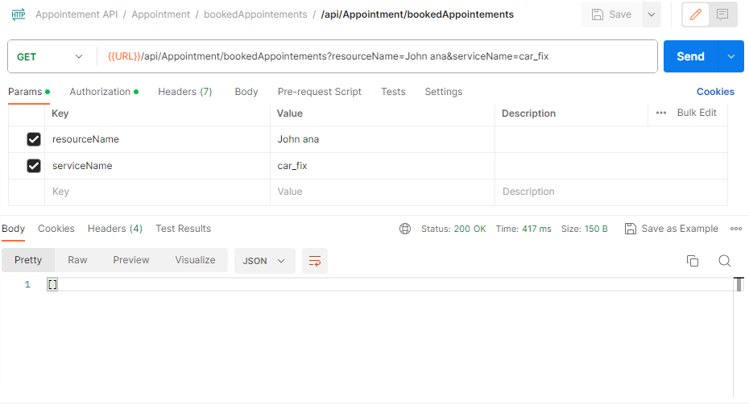

### **7. Additional Information**

* Browser: Google Chrome, version 92.0.4515.159
* Operating System: Windows 10
* Date/Time of Occurrence: September 21, 2023, 10:30 AM

### **8. Impact**

The incorrect date display may cause confusion for users and lead to scheduling errors. It could result in missed appointments or incorrect allocation of resources.

### **9. Reproducibility**

The issue is reproducible consistently by following the steps mentioned above.

# 1. Bug Details

* **Bug ID:** BR-003
* **Title:** Empty Response body in Get available slots request
* **Module:** Appointment Module
* **Severity:** High
* **Priority:** Medium

### **2. Bug Description**

After scheduling a new appointment, the new appointment is not shown on the appointment page.

### **3. Steps to Reproduce**

1. Log in to the system.
2. Navigate to the Appointment Module.

### **4. Expected Result**

The appointment confirmation screen should display the available slots for the selected resources.

### **5. Actual Result**

The available slots screen displays nothing.

### **6. Screenshots**

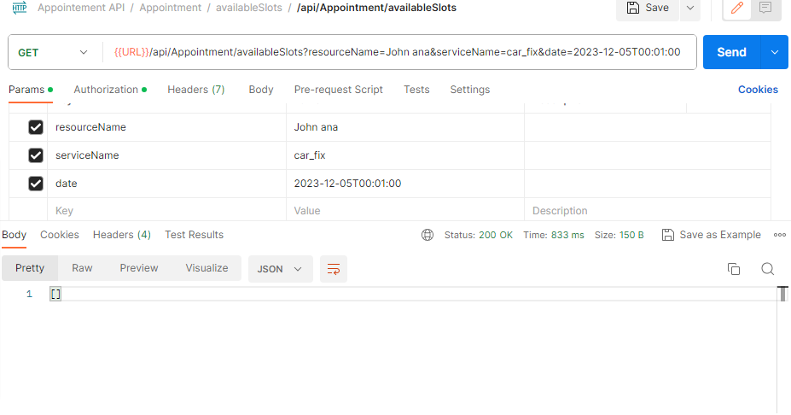

# 1. Bug Details

* **Bug ID:** BR-004
* **Title:** search for service with name is not working
* **Module:** services Module
* **Severity:** low
* **Priority:** low

### **2. Bug Description**

Can not search about a service with a name.

### **3. Steps to Reproduce**

1. Log in to the system.
2. Navigate to the services screen.
3. Click on the search bar and enter the service name.
4. Click enter

### **4. Expected Result**

The services screen should display the selected service that the user entered in the search bar.

### **5. Actual Result**

The services screen displays all services.

### **6. Screenshots**

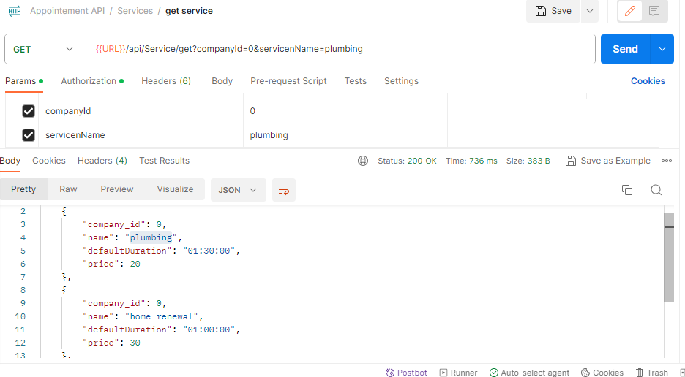

# 1. Bug Details

* **Bug ID:** BR-005
* **Title:** get a new resource with compant_id different from the one entered in resource creation
* **Module:** Resources Module
* **Severity:** High
* **Priority:** medium

### **2. Bug Description**

* after adding a new resource with a specific companyId like 4 and getting all resource in the response body the new resources is displayed with companyId 0

### **3. Steps to Reproduce**

1. Log in to the system.
2. Navigate to the resources screen.

### **4. Expected Result**

The services screen should display the selected service that the user entered in the search bar.

### **5. Actual Result**

The services screen displays all services.

### **6. Screenshots**



# 1. Bug Details

* **Bug ID:** BR-006
* **Title:** search about resource with name is not working
* **Module:** services Module
* **Severity:** low
* **Priority:** medium

### **2. Bug Description**

Can not search about a resource with a name.

### **3. Steps to Reproduce**

1. Log in to the system.
2. Navigate to the resources screen.
3. Click on the search bar and enter the resource name.
4. Click enter

### **4. Expected Result**

The resources screen should display the selected resource that the user entered in the search bar.

### **5. Actual Result**

The resources screen displays all resources.

### **6. Screenshots**

<https://drive.google.com/file/d/1Ey1E0mgjIIq4_9sEp6pdoRJozhbcC2ac/view?usp=drive_link>

# 1. Bug Details

* **Bug ID:** BR-007
* **Title:** Can not update resource
* **Module:** Resources Module
* **Severity:** High
* **Priority:** medium

### **2. Bug Description**

* Can not update an existing resource

### **3. Steps to Reproduce**

1. Log in to the system.
2. Navigate to the resources screen.
3. Click on the "Edit" button.

### **4. Expected Result**

The resources screen should display resource data to edit.

### **5. Actual Result**

The resource screen should display the error 404 not found.

### **6. Screenshots**

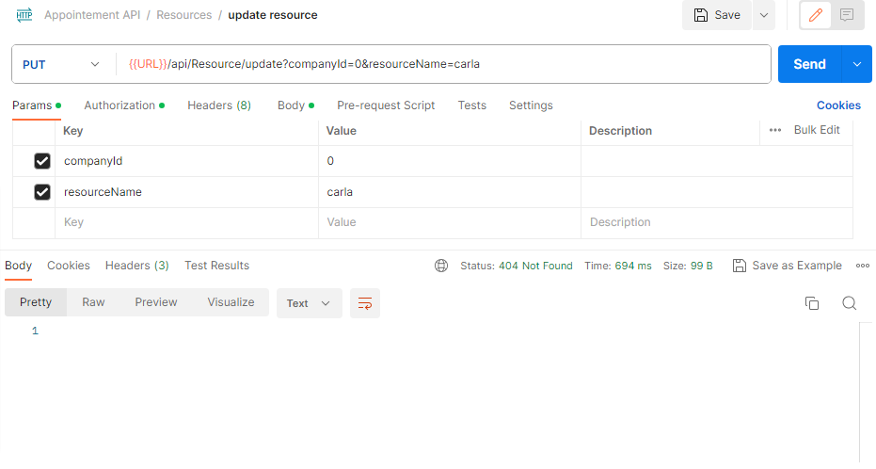

### **10. Environment**

* Application Version: Appointment Module v1.2.3
* Server Environment: Development/Test
* Database: MySQL v8.0.23